**Project Design Phase-II Technology Stack (Architecture & Stack)**

|  |  |
| --- | --- |
| Date | 03 October 2022 |
| Team ID | PNT2022TMID04471 |
| Project Name | Project - News Tracker Application |
| Maximum Marks | 4 Marks |

**Technical Architecture:**

The Deliverable shall include the architectural diagram as below and the information as per the table1 & table 2

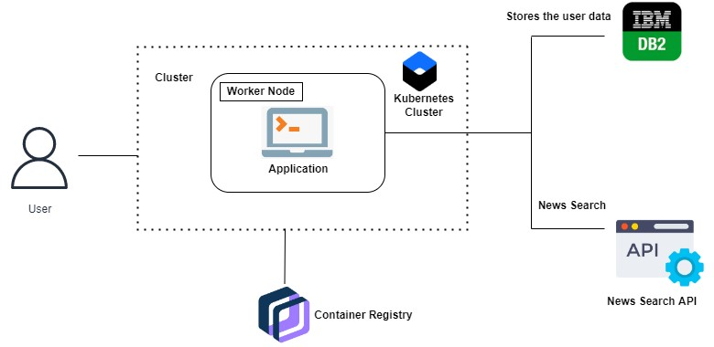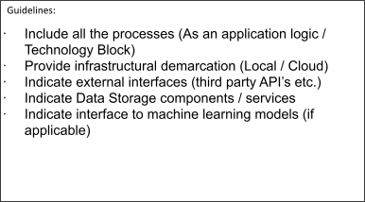

|  |  |  |  |
| --- | --- | --- | --- |
| **S.No** | **Characteristics** | **Description** | **Technology** |
| 1. | Open-Source Frameworks | List the open-source frameworks used | Flask |
| 2. | Security Implementations | List all the security / access controls implemented, use of firewalls etc. | Encryptions, IAM Controls, OWASP |
| 3. | Scalable Architecture | Justify the scalability of architecture (3 – tier, Micro-services) | Kubernetes |
| 4. | Availability | Justify the availability of application (e.g. use of load balancers, distributed servers etc.) | IBM Cloud |

**Table-1 : Components & Technologies:**

|  |  |  |  |
| --- | --- | --- | --- |
| **S.No** | **Component** | **Description** | **Technology** |
| 1. | User Interface | How user interacts with application e.g. Web UI, Mobile App, Chatbot etc. | HTML, CSS, JavaScript / React Js etc. |
| 2. | Application Logic-1 | Logic for a process in the application | Python(Flask) |
| 3. | Application Logic-2 | Logic for a process in the application | IBM Watson Assistant |
| 4. | Database | Data Type, Configurations etc. | MySQL |
| 5. | Cloud Database | Database Service on Cloud | IBM DB |
| 6. | External API-1 | Purpose of External API used in the application | Rapid API |
| 7. | Infrastructure (Server / Cloud) | Application Deployment on Local System / Cloud | Local, Cloud Foundry, Kubernetes, etc. |

**Table-2: Application Characteristics:**